Dog Wood Petresort Website content

Home page

Luxury Pet Accommodation, Grooming & Day Care Services

The Dogwood Ethos
Dogwood Pet Resort is a very special place. We provide our canine guests with facilities and a range of services that will exceed your expectations. Our guests will have a happy holiday of their own; from trekking in the woodland or indulging in a treatment at the Dogwood grooming studio.

Contact Us
028 9181 3466
07917 132 272
info@dogwoodpetresort.com
Contact Us

Find us on Facebook

Slider

Only the Best will do!
We promise cosy and comfortable rooms for all our guests.
• State of the art facilities
• Oversized rooms and family suites
• Underground heating & piped music
• Comfy beds, cosy blankets and even orthopaedic beds for our guests advanced in years

Best Buddies!
Dinky Dogs at Dogwood!
The fun never stops with our all weather playroom and play court for our special dinky dogs!

Everyone recognises our special Dogwood van!
We offer a convenient Pet Taxi Service and also a Dog Walking Service.

Special treats & Rewards with our Dogwood 'Refer a Friend programme'

Fun in the Fields!
We pride ourselves in providing fun and fulfilling days for our guests with a strong emphasis on exercise, health and encouraging good behaviour.
Pet owners can select a variety of activities or treatments to make their pets stay Varied, Stimulating and enjoyable.

Dog Day Afternoon! The Gang at Play...

Award Winning Team
Dog Sales & Dog Training
Paul has had tremendous success breeding and training...
Owners can choose to work independently with their trained or part trained dogs, or work under supervision

Pet Boarding
Facilities
Our purpose built facilities have been created to satisfy loving pet owners that want more than just a typical boarding establishment.
- Oversized rooms and family suites
- State of the art facilities
- Grooming studio
- Underground heating & piped music
- Private play parks
- Daily walks and activity programmes
- Day care
- Ministry approved
Following check-in, guests will be escorted to their accommodation, where they are encouraged to familiarise themselves with their room and private exercise run, before participating in the days activities.
Our rooms and family suites are spacious and feature underground heating and piped music. Each room benefits from its own large individual out door run. We provide comfy day beds and evening beds, blankets and orthopedic beds for our guests advanced in years.
Our premises have fire and intruder alarms and CCTV systems linked to our on site home. Rooms are thoroughly cleaned using high pressure steam avoiding too much use of chemical disinfectants.
The Dogwood kitchen will prepare all the meals to owners specific requirements and treats for those guests allowed to indulge.

Big Paws
Big fun is for all guests at Dogwood, but we understand that larger breeds have a lot more energy and pace to give each day and that’s why Dogwood has put together activity programmes only suitable for medium to larger breeds.
The usual walks and daily activities will suit all our guests, but for the Big paws you may wish to truly give your pet a work out by adding a trek or a monster trek whilst on their holiday. Our woodland and beach treks range from one hour and two hours for the Monster and of course all photographed for you to enjoy.
Guests will enjoy free play during their stay at Dogwood but you may wish to consider a one to one play session in one of our large and secure parks were your pet can be a Frisbee champ for the day or enjoy fetch and tug play with our play leaders.
Our Big paws will benefit from all the comforts within Dogwood, and will be accommodated within the medium to larger breed’s area, all our rooms are spacious, however, we do have extra large rooms, beds and family suites with the larger breeds in mind.

Facilities
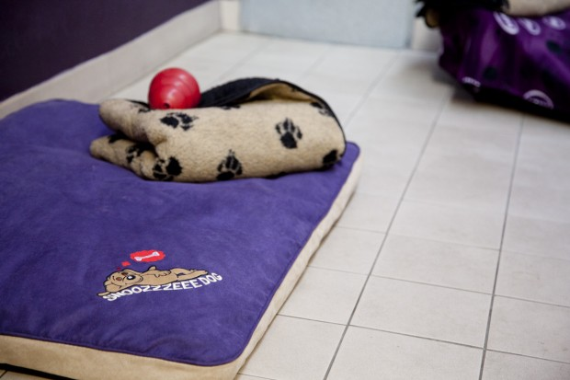
Our purpose built facilities have been created to satisfy loving pet owners that want more than just a typical boarding establishment.
- Oversized rooms and family suites
- State of the art facilities
- Grooming studio
- Underground heating & piped music
- Private play parks
- Daily walks and activity programmes
- Day care
- Ministry approved
Following check-in, guests will be escorted to their accommodation, where they are encouraged to familiarise themselves with their room and private exercise run, before participating in the days activities.
Our rooms and family suites are spacious and feature underground heating and piped music. Each room benefits from its own large individual out door run. We provide comfy day beds and evening beds, blankets and orthopedic beds for our guests advanced in years.
Our premises have fire and intruder alarms and CCTV systems linked to our on site home. Rooms are thoroughly cleaned using high pressure steam avoiding too much use of chemical disinfectants.
The Dogwood kitchen will prepare all the meals to owners specific requirements and treats for those guests allowed to indulge.
Pricing
Boarding Fees are £18 daily per guest (two dogs sharing - £16 per guest)
Cost is inclusive of food, heating, daily walks and email/regular text updates

SOMETHING SPECIAL...
We know that by choosing DOGWOOD you simply love your pets and desire the very best for them too. Take a look at our fun filled optional extras (all photographed.. so you can enjoy them too)
WOODLAND ADVENTURE TREK" £18 (find out more...)"]One hour trekking in our local woodland... sights, smells and stimulation with a well deserved brush, tidy and treat on return to DOGWOOD. A favourite with our campers.. Advisable to book early.
WOODLAND MONSTER TREK" (but nothing scary) £28"]For the truly energetic guest.. Two hours of trekking in our local woodland, including a swim in the lake to cool off hot paws. Sure to leave your pet happy and dog tired! Brush, tidy, treat and bath if required on return to Dogwood.
"HILLSIDE HAPPY TREK " £15]A local trek suitable for the Dinkies.. Hillside trekking covering an easy paced 3 miles on our back roads and lanes. Brush, tidy and treat on return to DOGWOOD.
LIFE'S A BEACH" £20"]One hour of walking, fun and play at our local beaches.. An enjoyable, tail wagging, trip with plenty of interaction from our play leaders. Brush, tidy, treat and bath if required on return to DOGWOOD.
"PLAY PARK" 45 MINS £12 (complimentary to day care/camp guests and DOGWOOD members)"]Fun and off lead in a secure play park either one to one with our play leaders or catching up with your doggie pals (graded guests only).. Ball play, bubbles,tug toys, and great times.... the guests so enjoy our parks ... doggie good fun!.

SOMETHING TASTY....
At DOGWOOD we know you so spoil your pets at mealtime.. We have put together some delicious delights for them to tuck into.. Of course we do understand that not all guests are allowed to indulge.
"SUNDAY SPECIAL" (but every day’s special at DOGWOOD) £5"]A huge helping of turkey/chicken served with brown rice and vegetables and drizzled in gravy... tasty and healthy!!
"SAMMYS SALMON SUPPER" £5"] Inspired by a regular DOGWOODER that just loves his fish. What a whopper! A full fillet of fresh salmon served with brown rice and a selection of vegetables.
"SAUSAGE SIZZLER" £3.00"] A big DOGWOOD favourite. served as a tasty starter at mealtime. 3 huge gravy drizzled sausages with toasty hearts...so yummy!!!
"CHRISTMAS DINNER" £8 ...ALL proceeds go to our chosen charity Fonic trust"] To find out more about the Fonic Trust please click here.
A fun and quirky day with Santa Paws himself!
suitable for all guests boarding over Boxing day and allowed to indulge in a side stuffing Christmas dinner.
Select from traditional Turkey/ham or Salmon fillet complete with all the trimmings served on a silver platter.
Don’t forget to wrap and label your Pets Christmas gift ... Santa paws will be delivering lots of presents to all our good doggies.
A fantastic day that annually raises much needed money for those in need.

Opening Times
MON 09:00-10:30 AND 16:30 -17:30
TUES 09:00-10:30 AND 16:30-17:30
WEDNESDAY CLOSED.... (OPEN WEDNESDAY''S - ONLY FOLLOWING BANK HOLIDAYS)
DOGWOOD OPERATES EVERY WEDNESDAY DURING THE MONTH OF JULY, 09-1030 AND 1630-1730 WITH EXCEPTION OF 13TH JULY , AM ONLY
THUR 09:00-10:30 AND 16:30-17:30
FRI 09:00-10:30 AND 16:30 -17:30
SAT 09:00-10:30
SUN 09:00- 10:30
‘EARLY PAWS’ MID WEEK CHECK IN 07:15-07:45 SHARP
COMPLIMENTARY AND UNLIMITED TO DOGWOOD MEMBERS.
PRE- BOOKABLE IN ADVANCE FOR NON DOGWOOD MEMBERS (TERMS APPLY)
EXCEPTIONAL CLOSURE NOVEMBER 2016
DOOGWOOD WILL BE CLOSED FOR ANNUAL MAINTENANCE AND STAFF LEAVE 01ST NOVEMBER 2016 UNTIL 1ST DECEMBER 2016, WE RESUME NORMAL HOURS ON FRIDAY 2ND DECEMBER.

GALLERY

FAQs
[toggle title="Which vaccinations are required?"]It is essential that all guests have an up to date annual booster and kennel cough administered... We prefer that pets have had any veterinary treatments and inoculations at least 5-7 days prior to boarding at Dogwood. Please bring your vet record card to check in. [/toggle]
[toggle title="What should I bring to dogwood for my pets stay?"]At Dogwood we provide everything that our guests will need, from beds to bowls, we only use our own bedding and blankets. Dogwood house keeping will refresh your pet’s blankets every two days.
You may bring:
.Own treats (bagged and name labelled please)
.medication (only vet prescribed medication will be accepted and in original container)
.scent object (t-shirt, pillow case or towel with your scent on it)
.durable toy (one per pet) must not be very small or destructible item (Choking hazard)[/toggle]
[toggle title="How should I check in?"]Please arrive at the reception area within good time of your check in as the reception staff may need to ask a few questions about our new guest and to check your vet’s inoculation records. Pets must be on a lead and must not enter the reception until the area is free of other guests checking in or out. It is advisable to leave your pet in the car to check the boarding paperwork prior to your Pet entering Dogwood. Dogwood will not permit children within our reception. Please note our reception area can be very busy at peak times.[/toggle]
[toggle title="I need an ‘Early Paws’ check in... But I am not a Dogwood member?"]Dogwood operates the ‘Early Paws’ check in to all guests, non dogwood members will be charged £12 per guest or per family checking in. As the ‘Early Paws’ is a limited time (0715-0745) and can be busy, we request that all paperwork and vet records are checked in advance of the day of boarding.
Non Dogwood members must pre-book ‘Early paws’, the service is complimentary, unlimited and booking in advance is not required for Dogwood members.[/toggle]
[toggle title="Can I tour the Dogwood facilities? "]At Dogwood, we certainly do like to meet customers and discuss your Pets needs. Our busy reception area is also adjoining to our grooming studio and it is not always possible to escort persons within our premises during peak times. We are more than happy to show customers a standard room from our lobby area and but full tours will not be available as our walk ways are not insured to the public.[/toggle]
[toggle title="I wish to refer a friend for boarding, day care or day camp."]Fantastic news! Dogwood will be delighted to introduce a new guest to the fun of Dogwood. Existing customers should email or mention the referral at check in. following a new customer booking we will be delighted to award you both with half price fees for your first day or boarding or day services.[/toggle]
[toggle title="I am anxious about leaving my pet, will I hear from Dogwood during my Pets stay?"]We understand that it is not easy leaving your Pet to board, especially if both owner and Pet is new to the experience. Part of the Dogwood service is to contact owners whilst they are away. Dogwood will forward a text to the owner following 48 hours and will send photos of your Pets holiday via email. If you are extremely anxious, or need daily feedback we would encourage you to book a special care plan with your reservation.[/toggle]
[toggle title="Feeding at dogwood"]Guests at Dogwood will be served two meals daily, serving times are 12-1 and 7-8. We stock premium brand dry kibble, wet food and small breed trays. Milky bones, bonios and dental sticks are all served complimentary. If you prefer to supply your own pet’s food please supply it in a resalable container and labelled with your Pets name. It might be worthwhile to provide a little more food than usual, as our guests are probably more active than normal whilst at Dogwood. Please note that guests will not be served breakfast on the morning of check out, only guests that are diabetic or on medication will be served a morning meal.[/toggle]
[toggle title="I have a recently rescued a pet, is it possible to use Dogwood for boarding or day service?"]For Dogs that have recently been adopted from a rescue shelter, we require a 30 day period before we can accept them into Dogwood Pet Resort. This is a precautionary measure to ensure that the dog is free of any communicable illnesses that may have been contracted at the shelter.[/toggle]
[toggle title="What happens if my pet becomes unwell during time at Dogwood?"]Guests boarding at Dogwood should arrive in good health, however Dogwood will not hesitate to request the services of a vet, should we feel guests seem unwell. Dogwood is linked with two local vets and an out of hours vet service.[/toggle]
[toggle title="My dog is sociable; can they interact with other dogs?"]Pets that are sociable are encouraged to grade under our day care programme, this takes four sessions to enable our play leaders to access your pet’s temperament and to see if they are suitable for team play. Dogwood will not allow ungraded dogs to join in group play. Day care to day camp grading is a fantastic way to add on more fun when pets check in for a holiday as they automatically will be included group play with friends they have previously established. (Terms and conditions apply) [/toggle]

Terms
THIS AGREEMENT OUTLINES THE TERMS OF YOUR PET OR PET'S STAY (HEREAFTER THE TERM 'PET' WILL HAVE A SINGULAR OR PLURAL MEANING) THE OWNERS AND DOGWOOD PET RESORT LTD AGREE TO THE FOLLOWING. THE TERM RESORT WILL APPLY TO DOGWOOD PET RESORT AND BALLYSKEAGH CATTERY AND GROOMING.
1 The owner hereby certifies to the accuracy of all information given about the pet. The owner specifically represents that the pet has not been exposed to distemper, rabies, and has not been ill with any communicable condition within a 30 day period prior to boarding at the Resort. The owner verifies that all vet records showing up to date booster and kennel cough (administered no less than TEN days prior check in) will be produced prior to pet check in at Dogwood, failure to produce valid certification will automatically result in declined admission to board. Pets displaying signs of illness at check in will be refused entry.
2 The owner represents that his/her Pet has not bitten or shown any aggressive or threatening behaviour toward any person, child or animal, except as described in this paragraph.
---------------------------------------------------------------------------------------------------------------------------------------------------------------------------------------------------------------------------------------------------------------------------------------------------------------------------------------------------------------------------------------------------------------------------------------------------------------------------------------------------------------------------------------------------------------------------------------------------------------------------------------------------------------------------------------------------------------------------------------------------------------------------------
3 The owner understands that he/she is solely responsible for any harm caused by his/her Pet to any person, other pets or the property whilst the owner's pet is a guest or using Pet services at Dogwood Pet Resort.
4 The owner understands that he/she is solely responsible for their Pet on the premises at the Resort prior to Dogwood Staff escorting the Pet after check-in/out. The Owner understands that the Pet must be secure on a lead and muzzled if required, the owner understands to not enter the reception area with the Pet should another Owner or Pet is within the reception area. It is essential that all paperwork is completed before the Pet is brought into the reception/check-in area. Please contact Dogwood if you have concerns about your pet and their beheaviour when checking in. pre opening check in/out can be arranged on request. Pets must wear a secure collar with identification and be licensed.
5 The owner understands and agrees that in permitting his/her Pets to participate in group activities and treks that the owner understands that Pets, when in groups, can accidentally injure each other while playing. Minor cuts, scrapes, bite wounds and bruises are a possibility and not unexpected as a result of group participation. The Resort and staff will not be held responsible for incidents within or outside the resort as a result of the Pet's attendance of boarding, day camp, day care, treks and all activities and services.
6. The owner certifies that if the Pet will be participating in day camp and group activities that the Pet is spayed or neutered. Pets participating or wishing to participate in day camp will be required to undergo grading to determine if suitable for group activities. Day care is offered to all Pets.
7. Owners requiring their dogs to share accommodation understand that Dogwood Pet Resort and staff will not be responsible if the pets injure each other as a result of sharing a room together.
8.If a Pet becomes ill, or if the state of the animal's health otherwise requires professional attention, Dogwood Pet Resort, in its sole discretion, may engage the services of a veterinarian or administer medicine or give other requisite attention to the animal, and the expense thereof shall be paid by the Owner. Dogwood will only administer medication as prescribed by their vets. In the very unfortunate circumstances of a pet death at Dogwood, the resort will carry out an investigation with the assistance of a veterinarian should the death be premature, or of an otherwise healthy (condition free) pet. Dogwood will contact the owners directly for instructions as to cremation/burial or collection from the nominated contacts should the owners be unavailable. Dogwood will not bear any costings for veterinarian fees, pet cremation or burial. Owners of deceased pets will receive veterinarian written reports as to the cause of their pets death. For the welfare of other boarding guests Dogwood reserves the right to have any pet death investigated by a veterinarian.
9. Dogwood Pet Resort shall exercise care and attention for the Pet delivered by Owner to the Resort for any Pet services. It is expressly agreed by the Owner that the Resort's liability shall in no event exceed the lesser of the current chattel value of a Pet of the same species, or the sum of £500.00 per animal brought to the Resort for boarding, day camp, grooming, training, or any combination thereof.
10. The Resort will make every effort to return items left with Pet. However these items may not be returned or they may be returned in poor condition. The Resort is not responsible for said items. Dogwood Pet Resort will not accept any beds/bedding and will not accept any toys that are unsuitable or in poor condition. Pet toys that are specifically made for pets will only be accepted at Dogwood. Dogwood will not accept rawhide chews, toys or treats that pose a threat of choking.
11. Bathing ‐ all guests of the Resort, if their stay is longer than 4 days may receive a basic bath (wash and dry) at the Owner's expense as deemed necessary by Resort staff. Dogwood expects Pets to be in clean condition on arrival for boarding, basic baths/flea treatments or worming may be given to pets following check in, should they have soiled or dirty coats, all treatments will be charged to the owners account.
12. Grooming ‐ any grooming which takes place on an elderly animal or animal with health problems will be at the Owner's risk. Grooming may expose pre‐existing health/skin problems for which the Resort cannot be held liable. De‐matting/thinning out of matted hair may cause patchiness and hair loss. Consent to remove the matted hair is on this understanding. Pets deemed to be difficult to groom or in need of extra groom time or an additional groomer to assist will be charged a fee of £10 per hour or part there off. Owners failing to collect their Pets on time after the groom appointment will be charged a sitting fee of £6 per hour(fifteen minutes granted for late pick up’s) If the owner fails to collect their Pet after an hour the Pet will automatically be placed into day care at a further charge of £15 per day in addition to groom and hour wait fee. Customers boarding pets with high maintenance coats can arrange for the Dogwood groomers to daily or weekly complete a coat brush through and condition. Dogwood will not be responsible for coat matting whilst pets are in boarding.
3. All charges incurred by the Owner shall be payable upon date scheduled for the Pet's check out. The Pet shall not leave the Resort until all charges are paid by the Owner. Dogwood Pet Resort accepts credit/debit/maestro cards, but will not accept cheques. Deposits for Pet services at Dogwood Pet Resort are non refundable but valid for use within a four month period, subject to availability, providing the Owner has offered 72 hour notification of cancellation. if your pet is collected before the scheduled departure date, the full boarding fee applies.
14. The Owner agrees to abide by Dogwood Pet Resort’s policies regarding hours of operation, cancellation fees, payment of services, vaccination requirements and other operational and safety regulations. Dogwood will advertise any exceptional closure days on the website within good notice. Dogwood club membership fees are valid for one year and to be paid in full upon each registration or renewal date membership.Dogwood membership is not available for purchase May-September.
15. The Owner gives permission for publication of photos or video taken of Pet and/or Owner by the Resort. The Owner understands that owner will not be paid any royalty or other compensation and hereby relinquishes any and all rights for payment if a photo or video of Pet and/or Owner is published in any form or medium.
16. If the Resort determines that the Pet requires special handling, the Resort reserves the right to charge the Owner a £10 daily special handling fee.
17. Day care guests that have not been collected at check out time will automatically be boarded for that evening, the full boarding fee will apply in addition to the day care fee. Dogwood members can extend daycare/camp to an overnights stay with a discounted charge of £9.
18. Dogwood Pet Resort will administer medication to pet’s as prescribed by a vet. Charges do not apply for administration of tablets,dressings etc. injections are charged at £1 daily. Diabetic guests are encouraged to complete a taster day prior to boarding. Dogwood will permit vet visitation at the owners request if required, we request that vet visits are within our operational times.
19. In the event of a Pet being extremely unsettled and disruptive to other guests within the resort. The customers nominated contact will be requested to remove the Pet from Dogwood. Should the nominated contact not accept the owners pet, a special handling fee will be applied to the owners account at a charge of £10 daily. It is essential that all pets boarding or using day services at Dogwood provide a reliable nominated/emergency contact.
20. Children are not allowed inside Dogwood Pet Resort at any time.
21. Dogwood operates a very busy facility and we do not permit full tours due to insurance restrictions, unless a scheduled open day has been arranged. Dogwood will be very happy to meet and discuss new clients and a view of our facilities can be inspected from our lobby area. As our reception is within our groom studio we cannot allow customers to enter whilst grooming is in process, therefore it is advisable to telephone/email your request in advance and we can arrange suitable meeting times.

This agreement contains the entire agreement between parties. All terms and conditions of this Agreement shall be binding on the representatives and assigns of the Owner and Resort. This contract shall remain in effect for subsequent transactions between the Pet Owner and Dogwood pet Resort, Dogwood grooming and ballyskeagh grooming and cattery.
ACCEPTED AND AGREED ON
DATE.................................................................................. OWNERS NAME PRINT.......................................... VETERINARY NAME......................................................................
NOMINATED CONTACT NAME............................................ OWNERS SIGNATURE........................................... VETERINARY CONTACT NUMBER..................................................
NOMINATED CONTACT NUMBER ...................................... OWNER CONTACT NUMBER.................................

Testimonials
We just want to say thank you so much to all the staff at Dogwood for providing Midi with a safe and welcoming home away from home.
Mr and Mrs Hunter, Lisburn
The standard of care and attention is second to none and Megan loves to meet other dogs and get out for walks and playtime. We would have no hesitation in recommending the Resort...
Derek Patterson
Hey there, we have had many holidays at Dogwood Pet Resort and have had the most fabulous time possible!
Reuben and Zack
I would highly recommend Dogwood as a pet resort. Rosco has his own personal holiday and thoroughly enjoys his time there.
Susie Davis
Sending my wee Buddy to Dogwood was the best thing I ever did...
Karen Murphy (Buddy's mummy)
As a regular user of Dogwood I regard it as Tia’s second home, there is genuine affection between her and the staff and I trust them 110% with her care. I'd recommend them to anyone.
Gary Weir
Mel, our mental springer spaniel, has stayed at Dogwood during our holidays and breaks over the last 3 years.
Kathryn
Last year I made the decision to put her in kennels when I was holidaying, but to be honest, I was terrified. Where could I go to have my spoilt pooch looked after the way I look after her? Then I was recommended to Dogwood!!
Deborah
I have been going to Dogwood Pet Resort since it opened- it is a really great place & I like going on holiday as much as my owners.
Schumi (Jack Russell)
We just want to say thank you so much to all the staff at Dogwood for providing Midi with a safe and welcoming home away from home.
Mr and Mrs Hunter, Lisburn
As the owner of a rescue dog which had been ill-treated, I found myself in somewhat of a quandry when I was going on holiday. Arrangements which had been in place for looking after my previous dog were no longer suitable. A friend recommended Dogwood and this proved to be the answer to all my concerns.
Valerie Ireland. Belfast.

Dinky Dogs

Dinky Dogs at Dogwood!
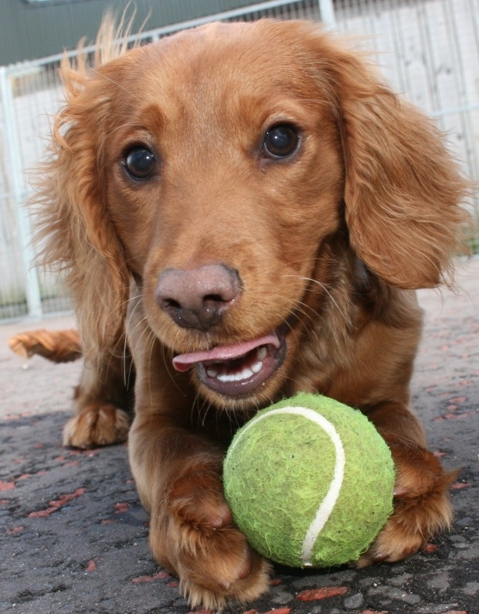No need to worry about your pet feeling anxious about the ‘Big Paws’ within Dogwood, we have a designated Dinky Dogs Zone to ensure the little ones can be happy and relaxed and have the most amount of fun!
We have an all weather playroom that is exclusive for the ‘Dinkies’ that adjoins to the Dinky Dog play park and our guests can choose at leisure where they wish to play. Our play leaders will supervise all activities at all times.
The play room has individual pods for our daily nap-time. When guests can enjoy their lunch in peace before afternoon play.
Following a day of walks and play, guests will be escorted to their rooms within the Dogwood accommodations.

Day Care

Day Care and Day Camp...
Busy lifestyle? Why leave your Pet lonely at home all day! The perfect worry-free alternative to a bored dog is a Day Care or Day Camp programme. Pets can either be dropped off on our ‘Early Paws’ 0715 -0745 check in or later during our regular hours 0900-1030. Day guests will enjoy a structured day of play, walks, lunch and care. Check out is 1630-1730, and pets will go home relaxed and ready to rest by your side.
Dogwood Day Care looks after your 'best friend' with walks in the countryside, playtime in our custom-built play parks or a peaceful rest in our comfortable guest rooms.
A vital service for you and your dog. Peace of mind that your pet will be cared for completely and in a safe and fun environment.

What is the difference between Day Care and Day Camp?
Any guest arriving at Dogwood for day services will automatically be placed into Day Care. Over four day sessions, our play leaders will supervise, access and grade each guest on temperament and ability to join in group play, we understand that most Pets just want to enjoy their special ‘pack time’ with their new doggie pals; however for some, interaction is just not their thing!
Dogwood has many guests in both Day Care and Day Camp, but equally they will enjoy the benefit of play park time either on a one to one basis with play leaders of mixing with their pals.
When Dogwood is satisfied and Pets have met the criteria they will be invited to move up to Day Camp, participating in daily group play. Pets that are neutered/spayed will only be able to join day camp. If you plan to use Dogwood day services regularly it may be worthwhile taking a look at our Dogwood membership, with great benefits for you and your Pet.

'EARLY PAWS' Dogwood operates the 'Early Paws' check-in for those that just need an earlier start to the day 07:15- 07:45 sharp!
'Early Paws' is for 'incoming guests' only on Day services or boarding and is subject to an annual fee for Dogwood members or a daily fee of £12 for non members on day service or boarding. Following our 'Early paws' check in time Dogwood will close until our regular opening time of 09:00-10:30. Check out after day services is 16:30-17:30 however, Dogwood members can delay check out with our 1630-1745 time extension.

Facilities
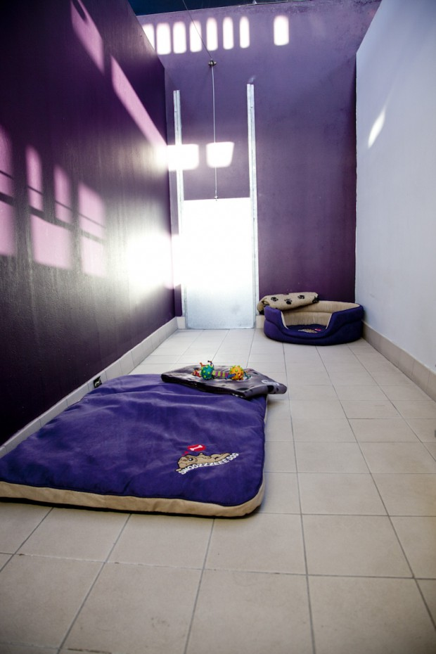
Dogwood Pet Resort is a very special place.
We provide all our canine guests with facilities and a range of services that will exceed your expectations.
Our guests will have a happy holiday of their own; from trekking in the woodland or indulging in a treatment at the Dogwood grooming studio.
- State of the art facilities
- Private play parks
- Daily walks and activity programmes
- Oversized rooms and family suites
- Underground heating & piped music
- Grooming studio
- Ministry approved

Pricing

Dogwood Day Camp & Day Care
£15 Per day, members and non members.
0900-1000 check in 16:30-17:30 check out. Monday, Tuesday, Thursday, Friday.
Available to Dogwood club members only: Early Paws and late check out.
07:15-07:45 check-in 16:30-17:45 check out.

Dogwood boarding
£18 per day check in 09-1030, next day check out 09-1030. Pm check out available mid week only 1630-1730
Early Paws available for all mid-week check in’s, complimentary and unlimited for members, £12 charge for non members.

Taste of the Action!
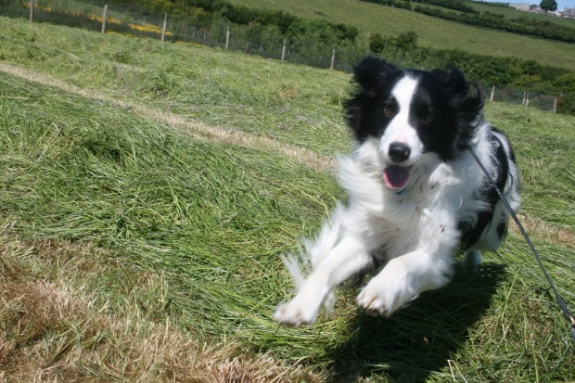New to boarding or Day Care?
Our taste of the action programme is designed to ease your pet into enjoying accommodation and care outside of your home.
Our team at Dogwood will welcome each guest and will encourage your Pet to feel secure in their new environment for the day.
Following walks and fun at the play park your Pet will check out feeling reassured that you did come back for them.. Makes it all the easier when returning to board!
Taste of the Action operates 10am – 1630 Monday, Tuesday,Thursday, Friday. £12 daily

Members Club

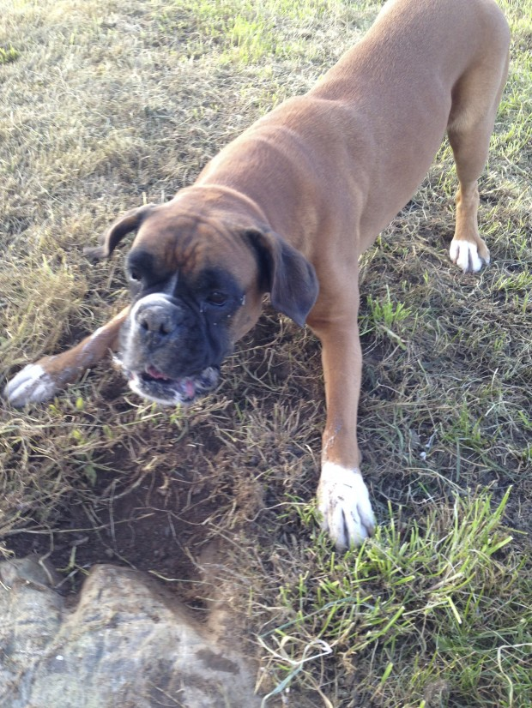

TIA… Digs being a dogwood member!

Dogwood Club Annual Membership

Fee £60

Peak dates guaranteed to Dogwood club members
1 complimentary woodland adventure trek worth £18
1 complimentary day camp worth £15
Complimentary unlimited mid week ‘Early Paws’ check in 0715-0745 sharp…. worth £12 per check in.
Dogwood memberships are available for purchase , DOGWOOD offers limited numbers due to retainer and guarantee of rooms during peak season. available to purchase until 30 April 2016

Fabulous Fridays

Day care with a difference…
Following a day with your poochie pals, why not get fresh for the weekend and take advantage of our half price going home baths. Just mention to team Dogwood at morning drop off and we will make sure that your Pet is fresh and clean for your Friday pm. pick up.

Max
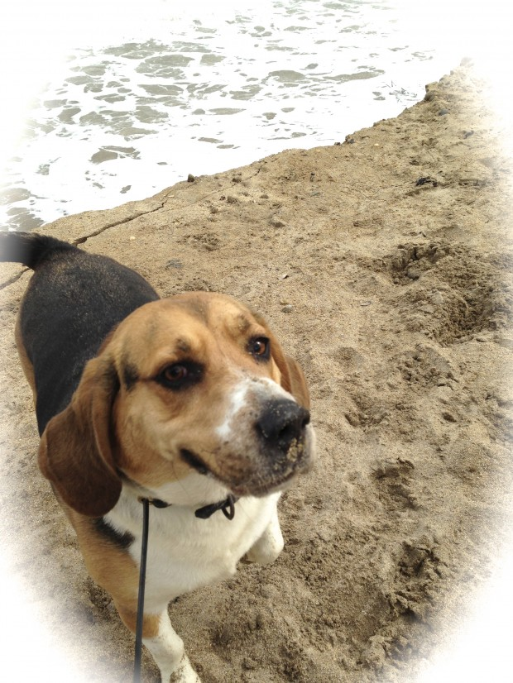

Opening Times
MON 09:00-10:30 AND 16:30 -17:30
TUES 09:00-10:30 AND 16:30-17:30
WEDNESDAY CLOSED…. (OPEN WEDNESDAY”S – ONLY FOLLOWING BANK HOLIDAYS)
DOGWOOD OPERATES EVERY WEDNESDAY DURING THE MONTH OF JULY, 09-1030 AND 1630-1730 WITH EXCEPTION OF 13TH JULY , AM ONLY
THUR 09:00-10:30 AND 16:30-17:30
FRI 09:00-10:30 AND 16:30 -17:30
SAT 09:00-10:30
SUN 09:00- 10:30
‘EARLY PAWS’ MID WEEK CHECK IN 07:15-07:45 SHARP
COMPLIMENTARY AND UNLIMITED TO DOGWOOD MEMBERS.
PRE- BOOKABLE IN ADVANCE FOR NON DOGWOOD MEMBERS (TERMS APPLY)

EXCEPTIONAL CLOSURE NOVEMBER 2016
DOOGWOOD WILL BE CLOSED FOR ANNUAL MAINTENANCE AND STAFF LEAVE 01ST NOVEMBER 2016 UNTIL 1ST DECEMBER 2016, WE RESUME NORMAL HOURS ON FRIDAY 2ND DECEMBER.

GALLERY

FAQs

Grooming
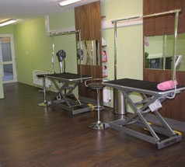Dogwood Groom Studio offers a full grooming service for boarding and non boarding pets.
Our professionally trained pet groomers shallprovide the greatest care throughout your pets grooming process.
- Bathing
- Clipping and scissoring
- Hand Stripping
- De-Shedding treatment
- Organic and specialised coat careproducts
- De Matting
- Ear/nail and gland care
- Maintenance plan
- Natural remedies
- Evening appointments available
Our modern studio offers the latest grooming technology featuring floor level walk-on tables catering for the elderly or larger pet, a walk in bathing system and the latest temperature controlled cabinet dryers to ensure a comfortable and positive experience.
After a relaxing bath your pet will be styled according to breed standard or owners specifications. We stock organic products and will use appropriate shampoos and conditioners depending on coat and skin condition. Every pet will benefit from regular grooming and it is important to your pets ongoing health care leaving them looking good and feeling great.
Prices for grooming will vary depending on breed /coat type discounted rates for boarding guests.
Contact us for a price and appointment.

Pricing
Grooming charges vary depending on various factors, including; coat condition, style required and duration of time that dog will be on the grooming table for.
Bathing starts at £12
Grooming from £25
(Discounts for boarders are available)
Please contact us for a quote and booking.
please note: Dogs deemed to be too dangerous to handle will be refused grooming.

Gallery
Terms
FAQs

Doggie Walker

Busy lifestyle?!
Let us take the lead and exercise your pet with interesting walks at our local beaches, woodland or your local area.
1 hour £12 per pet
2 hours £20 per pet
call our team to book a fun and fulfilling activity or trek.

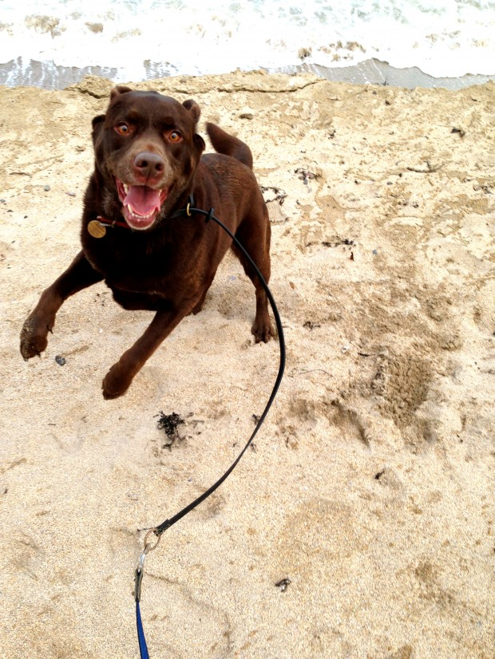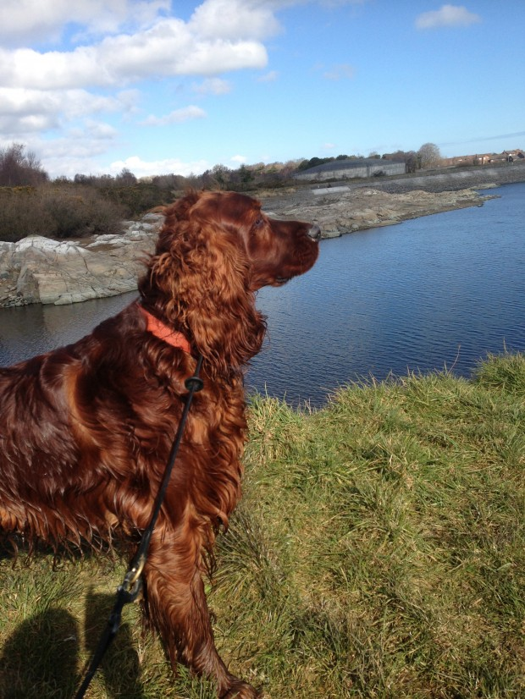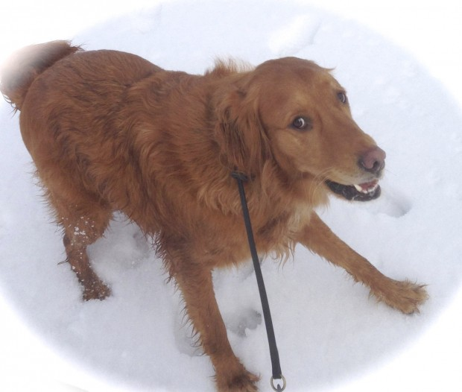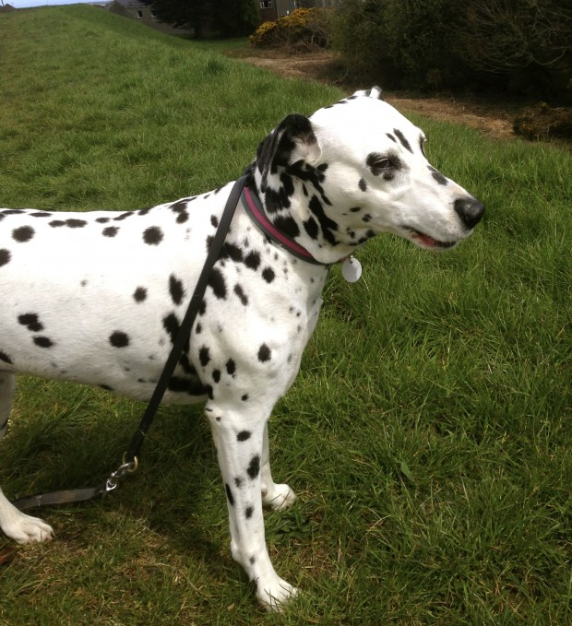

Pet Taxi
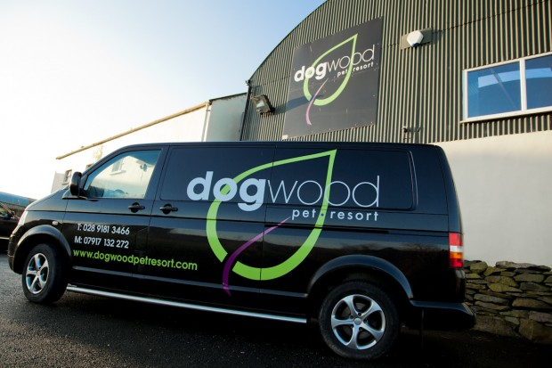Unable to get your Pet to your vet, groomers or your favourite Pet resort?
Dogwood has secure air conditioned transportation.
Contact Dogwood for pricing
or email us for more information

Latest News

Almost FULL house
Don’t say we didn’t try to tell you…. we are fast approaching our busy times and we would urge you to reserve your summer holidays, particularly July, as soon as possible.. don’t forget we only need a deposit of £40 per weeks reservation.. and we dont ask for a deposit from DOGWOOD members.
If you plan to have your pet graded prior a summer holiday, it would be advisable to get started with a taster or day care soon!.. we already have new day care members working up to their holidays… it makes a rewarding holiday for your pet if they are pre-graded as they will benefit from daily play park with no additional charges to your boarding.. if you need any further information regarding pet grading, don’t hesitate to give the Dogwood team a call!

Chester the chocolate Labrador enjoying day camp grading… off lead and playing with Alfie a regular Dogwooder! Well done Chester, we are all so proud of you!

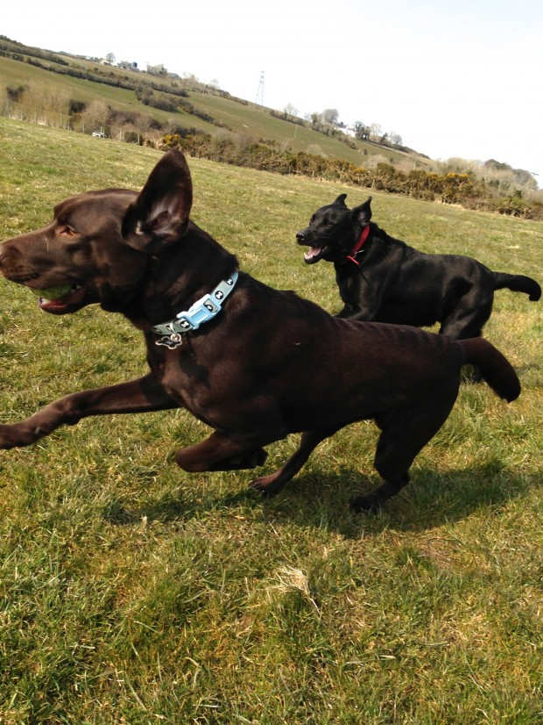

Featured Pet
All our guests are very special, so look out to see if your Pet is included in our Featured Pet section;
it’s worth a complimentary day care pass! or a bath at our grooming studio!
We update our featured Pet regularly, so make sure you contact us during your Pets 'Star Performance'.

Today’s featured Pet .. Gruffy
The sweetest natured Bernese mountain dog ... loving that he found DOGWOOD. Gruffy is always up for big fun in the fields and bouncy play in the play parks.. we all adore this big fella and if by chance the owners forgot to collect him... we might forget to remind them!! Come and collect your day pass Gruffy!
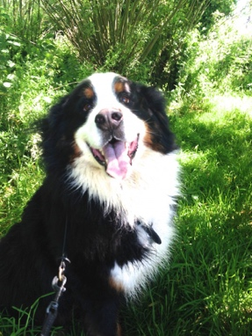

Fudge
A fantastic fun girl! and newbie to the daycare scene. Fudge has been warmly welcomed to fun days with her day care chums... a longer process for Fudge to learn recall and demonstrate pack play, but at last she has proved worthy of grading to off lead and now running with her pack... such a happy girl!well done Fudge! remind your mummy and daddy to pick up your complimentary day care pass.
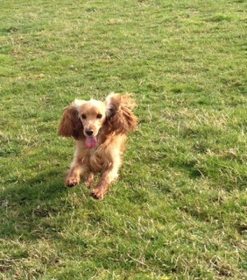

Tess
Tess the Lurcher... the fastest girl in the pack! Tess is a graded DOGWOOD member and is a fantastic team player, a very energetic girl that loves the freedom to run off lead in the DOGWOOD fields. Tess visits daily at day camp and benefits from the unlimited and complimentary 'Early Paws' service allowing a check in before our regular opening times, great for busy owners! Tess loves her toys, and being the speedy girl that she is will make it to the toy tubs in play park faster than any of her chums. Tess is a very affectionate, happy girl that has benefited greatly from her DOGWOOD experience. Your freebie daycare pass is waiting for you at the DOGWOOD reception Tess..well done!

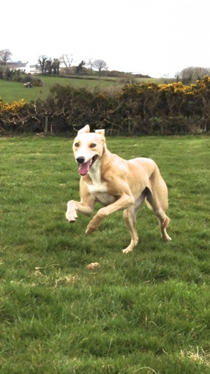

Carys
Introducing Carys the Corgi, also know as Miss sugar plum by her family! Carys is now a regular Dogwood member and so enjoys her fun filled days with her cousins Alfie and Herbie and all her new chums! A delight to watch at play park and running in the fields. Carys is besotted with her new pal Benson the Great dane pup.. what a match!! We so love Carys with her incredible energy and love for non stop play. see you soon chum and don't forget to pick up your free day care pass!
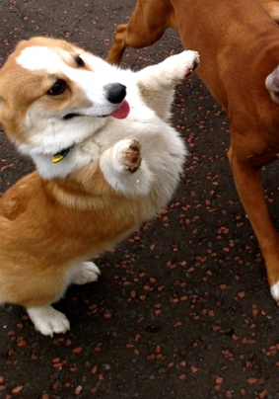

Muffy Murphy
Muffy is an onsite Dogwood dog, owned by Jenni and family... you may see her from time to time in the car park and she may attempt to delay you, by asking you to throw ball for her! Muffy is always keen to join in group exercise and activities in our fields and at play park, and the day camp girls so adore her. Muffy's favourite activity is bubble chase, particularly our bacon scented bubbles..she cant get enough of them!
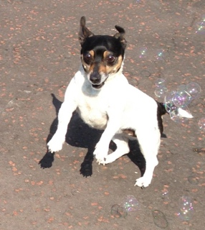

Bella
Introducing... the adorable Bella. Bella has recently joined the DOGWOOD membership programme and has benefited from the new member complimentary day care pass and enjoying the unlimited'Early Paws' available midweek at DOGWOOD. Bella has just finished her third day care and has so enjoyed off lead play in the DOGWOOD fields and play park time with her many new friends.. well done Bella! hope your Mummy and daddy notice you on the website.. It's worth another freebie day care pass!
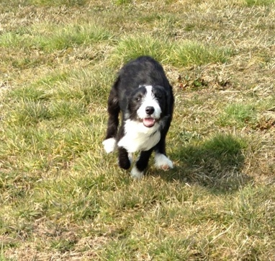

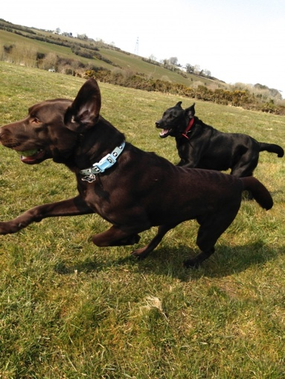

hours of operation SUMMER 2016
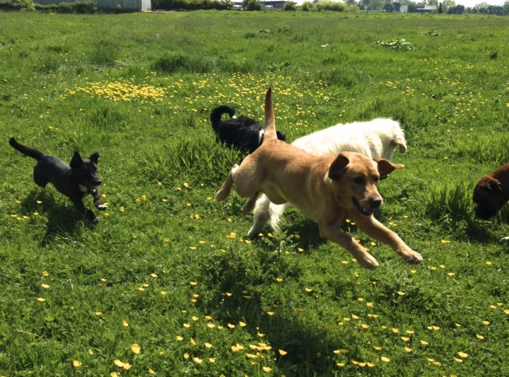

Last daycare/camp is Friday 08th July 2016, Daycare will resume again on Monday 18th July.
Monday 11th July DOGWOOD will operate 0900-1030 for boarding and check out guests only. CLOSED Tuesday 12th July .. OPEN Wednesday 13th am only 09-1030
Don't forget we open every Wednesday during July when we are normally closed.
For Dogwood members, the July fortnight room retainer release date is 4th July at 1030AM ... rooms will be released to awaiting guests following this date, if you have not informed us that you need a room for the busy July fortnight.

Tia and Bella... best friends!
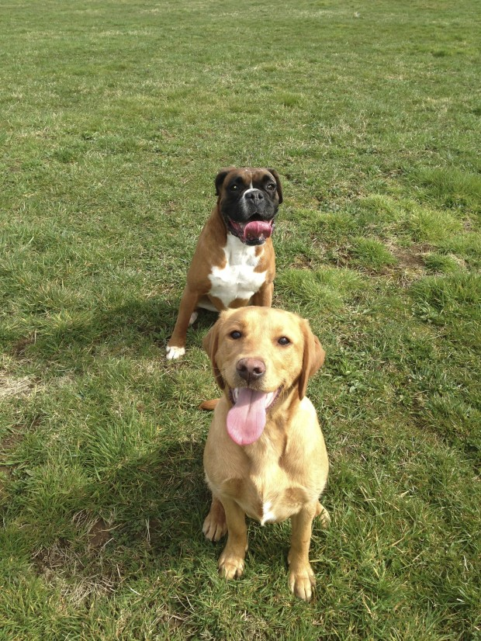

About us
Dogwood Pet Resort is a very special place. We provide our canine guests with facilities and a range of services that will exceed your expectations. Our guests will have a happy holiday of their own; from trekking in our local woodland, visiting the beach or indulging in a treatment at the Dogwood grooming studio.
Our purpose built facilities have been created to satisfy loving pet owners that want more than just a typical boarding establishment.
- Oversized rooms and family suites
- State of the art facilities
- Grooming studio
- Underground heating & piped music
- Private play parks
- Daily walks and activity programmes
- Day care
- Ministry approved
We pride ourselves in providing fun and fulfilling days for our guests with a strong emphasis on exercise, health and encouraging good behaviour. Pet owners can select a variety of activities or treatments to make their pets stay Varied, Stimulating and enjoyable.
Our rooms and family suites are spacious and feature underground heating and piped music. Each room benefits from its own large individual out door run. We provide comfy beds, blankets and orthopedic beds for our guests advanced in years. For our day care guests a comfy pod, for the dinky dogs or day bed for our big paws is provided over the lunch break and our one hour quiet time.
Our premises have fire and intruder alarms and CCTV systems linked to our on site home. Rooms are thoroughly cleaned using high pressure steam avoiding too much use of chemical disinfectants.
The Dogwood kitchen will prepare all the meals to owners specific requirements and stocks a variety of kibble and wet food, we also provide a menu for the guests that are allowed to indulge. Dogwood will provide a dental stick to each guest at our 9pm tuck down each evening.
Team Dogwood will contact and reassure owners with our updates during their pets stay via text and email within 48 hours of check in, daily updates are available for boarders with a special care plan. Day care and day camp guests will be updated via email daily at the end of each busy day.

Gift Vouchers available
The perfect gift for all Dogwood lovers.. Dogwood Pet Resort vouchers are now available to purchase at our reception for use on all our services.

Opening times

Refer a Friend Programme
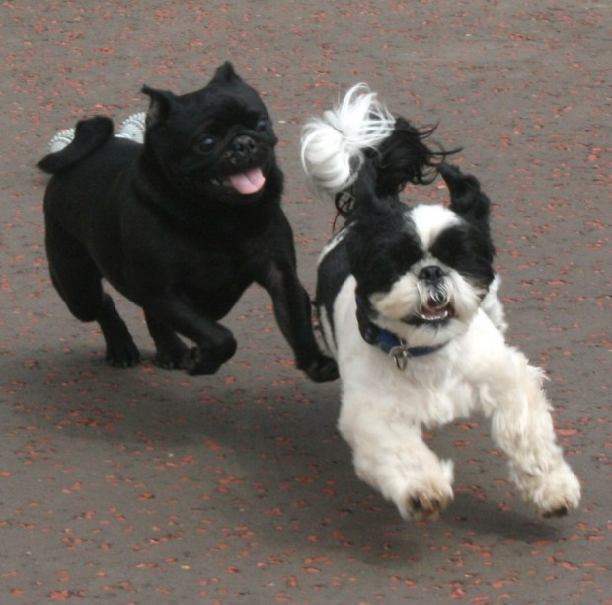Do you know someone who may be interested in bringing their Pet to Dogwood for Day Care or boarding?
You (and your friend) can get a full days Day Care or boarding for half the price..!
Just mention your friend and their Pet when you next call in or send us a quick email and we will credit your account when your friend makes a reservation.

Pets in Need

Thank you to all that helped.. Rocco is now re-homed!

A happy and much loved dog.
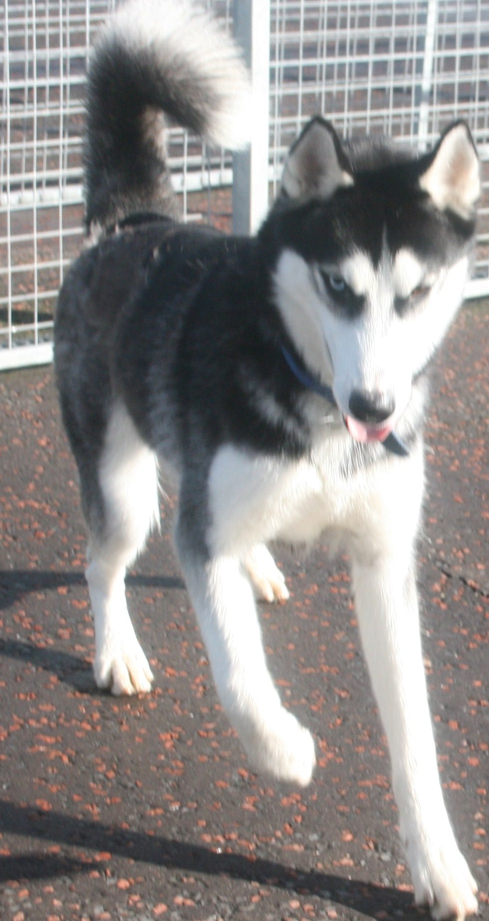

Dog Sale & Dog Training

Gun Dog Training
Dogwood has a large well stocked training enclosure with good coverage used to steady and train working dogs. Owners can choose to work independently with their trained or part trained dogs or work under supervision from our trainer at Dogwood.
1 £20 per 30 mins 1 dog
2 £35 per 30 mins 2 dogs
Training sessions are pre bookable. Please contact Paul 07860 491 679 or Dogwood reception to book a session.

Dog Sales
Dogwood is currently not selling any trained dogs.

Forget Me Not

Dogwood would like to thank you for the privilege of caring for your much loved Pets.
We have made many friends and enjoyed getting to know you. We would like to take the time here to honour our friends.

Thank You for the memories!

schumi
loved and cherished by the DOGWOOD team and Schumi’s very tentative owners Lorna and Peter.. Devastated by the very sudden departure of one of DOGWOOD’S first ever customers to visit! Schumi was a regular visitor and always relaxed in her usual cosy room 9, and enjoyed each and every DOGWOOD experience over the years. The picture below was the last one ever taken of Schumi at DOGWOOD, and although we have taken her loss so badly we will of course cherish the memories of the happiest ‘singing for her supper’ Schumi girl!.. our thanks to Lorna and Peter for thinking of us, in knowing that we so loved this special girl too. … for the love of dogs!! 17 May 2013
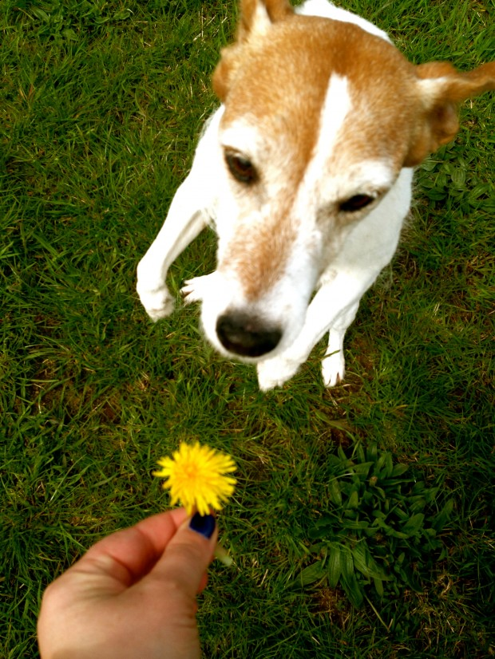

Reggie.
Fondest memories of our ‘one of a kind’..Reggie, known affectionately as Reginald. One of the first customers to walk through the doors at DOGWOOD and we so loved and greatly miss our big softie, chicken lov’in guy! Reggie was a big hit with the day camp team and was adored by Bella and Bailey, Weineramer’s just like Reggie. Reggie had a recent trauma and had a leg amputated, but our three legged Reggie coped fantastically and recovered to his former self… it was with great sadness that we recently heard of Reggies departure, however his life was happy and full of love from his attentive owners Caroline and Colin.

Buster.
Dogwood day campers have been shocked to hear of the sudden death of our youngest member.. Buster. An amazing playful and sweet natured sharpei-boxer cross that always visited each and every Thursday for day camp and fun times with friends. Buster will be so dearly missed by all his friends, Tia, Saffy, Kimmie, Bella, Jacob, Sammy and the entire team at Dogwood. Buster you were a great friend! much loved by owner Noeleen and family. 14 July 2012.
Dogwood recently purchased a beautiful young Bay tree and placed it beside the play park’s, the place that Buster so loved.. we call it ‘Busters Bay’ and it is a constant reminder of the happiest and sweetest dog we have known.
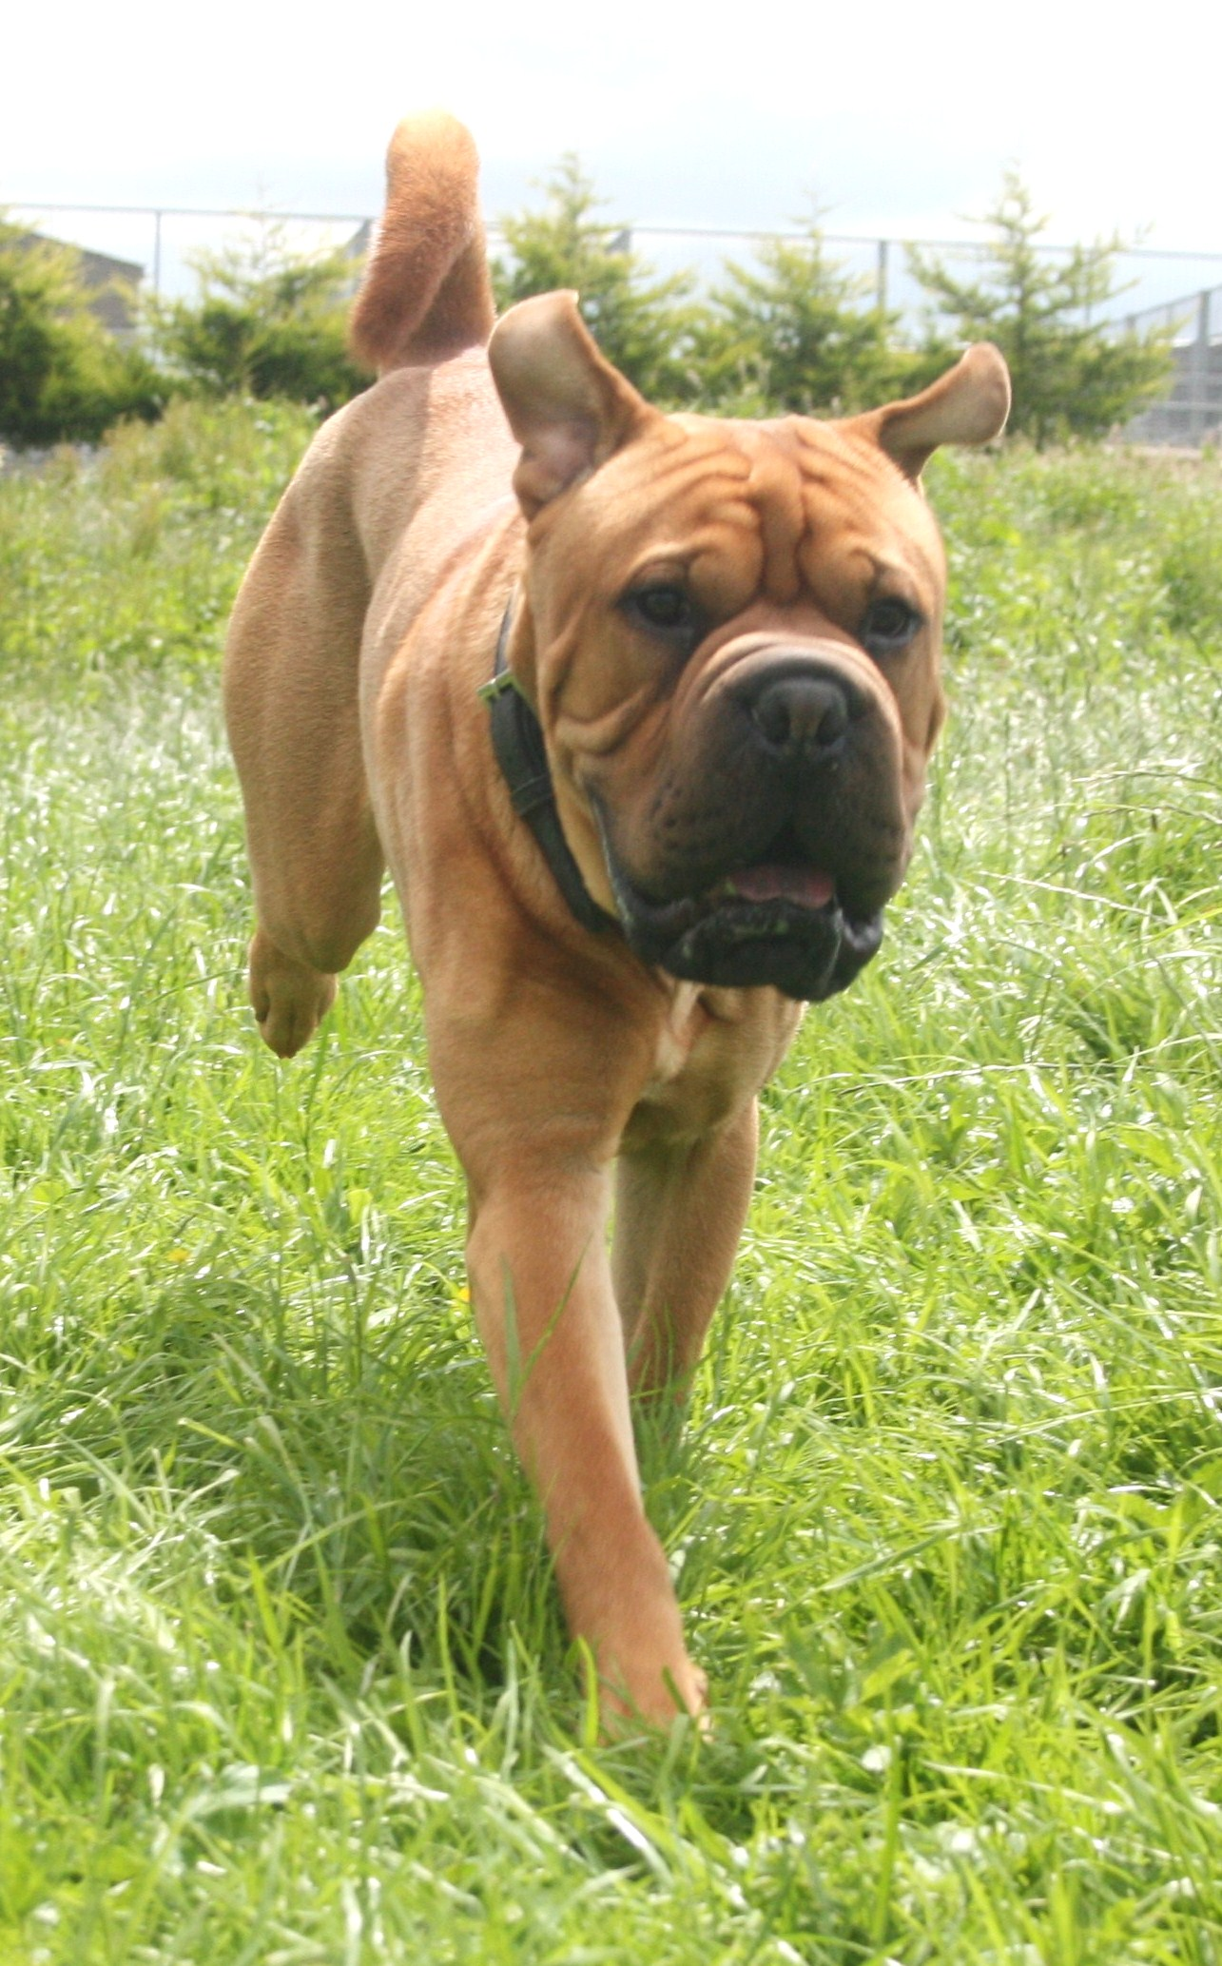

Buster enjoying free play.

Syd
Our very own Dogwood Pet, and friend to all guests. Syd not only was a wonderful family pet but a great working spaniel. Syd daily enjoyed helping team Dogwood and interacted with our guests during day care services and walks. Many happy years!
29 February 2012. Much loved.

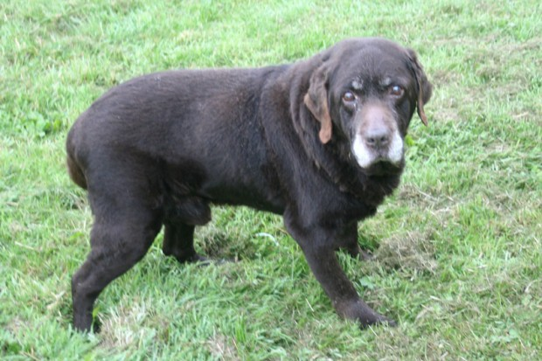Bailey
Remembering our very special Bailey (Bailey bear) an easy going, hug loving Labrador. Bailey always enjoyed his Dogwood days. Greatly loved and fondly remembered by his owners Sarah and Nick and all his friends at Dogwood.
06 February 2012

Recruitment
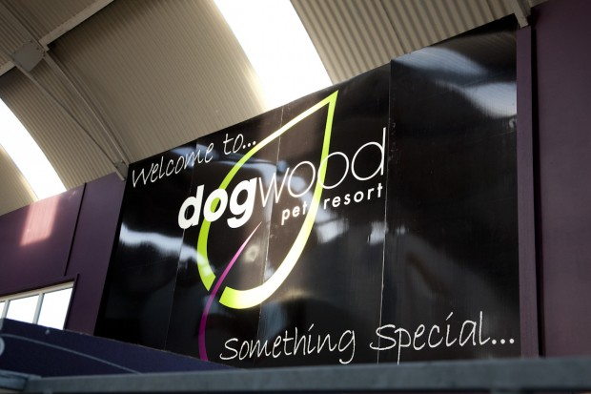
Dogwood Pet Resort has a position available for a Pet Groomer to join our team in a busy grooming salon.
The Position is available to only trained and experienced groomers that can work on a table rental basis either part or full time.
For more information contact Jenni at Dogwood

Supported Charities
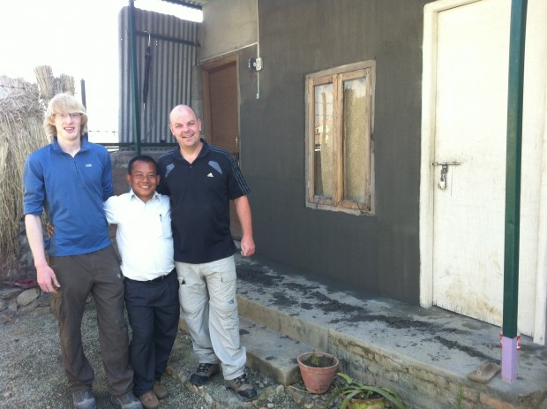Dogwood Pet resort is not only just committed to caring for our four legged friends… our chosen charity is Fonic Trust, a Northern Ireland registered charity that supports communities within Nepal.
For the last two years Dogwood staff and customers have given generously with our counter drop boxes and supporting our fun ‘Santa Paws’ day that is held each Boxing day.
In 2011 Paul from Dogwood visited Kathmandu and met the communities that benefited from monies collected, Paul as a skilled plasterer worked on buildings that needed much repair.
A special thank you to all that participated in our 2012 Santa Paw’s day.. we raised an incredible £161.07 (just for doggie dinners) and thank you to our customers and neighbours that dropped in gifts for our shoe box appeal for Fonic Trust and Team hope, we have amazing pictures at our reception showing young children delighted with their gifts. well done and thank you again to all that supported us.
To find out more about Fonic Trust visit www.fonictrust.org

Contact us
We are conveniently situated on the Crawfordsburn Road, Newtownards set in acres of countryside in the heart of County Down. We are just minutes from Newtownards and Bangor towns. On site parking facilities provided.
Dogwood Pet Resort
108 Crawfordsburn Road
Newtownards
Co. Down
BT23 4UJ
Tel: 028 9181 3466 answering service out of hours
Mobile: 07917 132 272 urgent and emergency contact only
Fax: 028 9181 3465
Email: info@dogwoodpetresort.com
Web: www.dogwoodpetresort.com

Directions/Map
We are conveniently situated on the Crawfordsburn Road, Newtownards set in acres of countryside in the heart of County Down. We are just minutes from Newtownards and Bangor towns. On site parking facilities provided.

